Setup instructions for using LibGDX

Jeremy Swartwood

Last updated 02/23/2018

# Table of contents

Table of contents 1

I. Download, Install, AND CONFIGURE Java SDK: 1

II. Download, Install, Configure Git for windows: 1

Download, install, configure github for windows 1

Create Token on Github for use with Android Studio 1

III. Download, Install, Configure Android Studio: 1

Download, Install, Configure LibGDX: 2

Example: Importing Awesome tower 2

EXAMPLE: Creating a LibGDX project, import to Android Studio, and upload to Github 3

# I. Download, Install, AND CONFIGURE Java SDK:

## I.1 Download Java JDK 8:

1. Go to the java downloads: <http://www.oracle.com/technetwork/java/javase/downloads/index.html>
2. Click Download  
   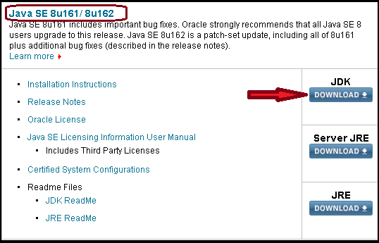
3. Scroll down to 8u161 or 8u162 and click I accept  
   
4. Click on the link for the version for your system  
   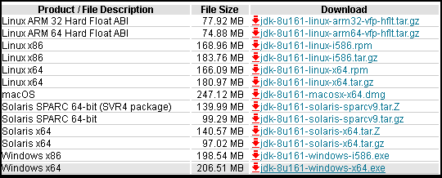

## I.2 Install the JDK.

# II. Download, Install, AND CONFIGURE Git for windows:

1. Download Git for Windows: <http://git-scm.com/download/win>
2. During installation, choose: Use Git bash only
3. Use OpenSSH (no need to configure other tools)
4. Checkout Windows-style, commit unix-style line endings. (Save from issues with platform specific repositories)

# III. Download, install, and configure github for windows

(This is **optional**, and only if you want a GUI to access github beyond git’s gui)

1. Download from here: <https://windows.github.com/>
2. **(Optional)** On GITHUB, you should setup an SSH key to access your data without using a password
   1. Generate an SSH key
      1. <https://help.github.com/articles/generating-ssh-keys/>
   2. Setup and use the SSH key
      1. Upper right of the webpage, click the COG to open settings.
      2. Click on the SSH Keys tab.
         1. Click Add SSH Key
         2. Enter a name, and paste the SSH key.
3. Install Github for Windows, and use the SSH key instead of a username and password.
   1. I just use my username and password because I’m lazy.

# IV. Download, Install, AND CONFIGURE Android Studio:

1. Download Android Studio Bundle for Windows: <http://developer.android.com/sdk/index.html#top>
2. Open and run the installer: android-studio-bundle*.exe
   1. Select all components and click next
   2. Pick the appropriate drives/locations for files: Changed to D: drive
   3. Accept all other defaults
3. Open Android Studio:
   1. Select the JDK location (***NOTE:*** *Since JDK 8 is out, it will complain about 7 not being up to* date)
   2. Select Standard installation.
   3. Accept and next to update SDK/API/etc.
4. Add Packages:
   1. <http://developer.android.com/sdk/installing/adding-packages.html>
   2. Click Configure -> SDK Manager
      1. Tools:
         1. Andoird SDK Tools
         2. Android SDK Platform-Tools
         3. Android SDK Build-Tools
      2. Android 5.1 (Or latest version)
         1. I just left all checked.
      3. Any previous android version you want.
      4. Extras
         1. Android Support Repository
         2. Android Support Library
         3. Google USB Driver
         4. Google Repository
         5. Google Play services
5. Configure GIT settings:
   1. (NOTE: This may no longer be needed, I have not tested this on a fresh install)
   2. Configure -> Settings
   3. Version Control -> Git
   4. Enter the path to your installation of GIT
      1. D:\Program Files\Git\bin\git.exe
   5. Enter your Github Token

# V. Download, Install, AND CONFIGURE LibGDX:

This is the framework that is similar to the old C# XNA Game Studio’s library.

* <http://libgdx.badlogicgames.com/documentation.html>

## Download Steps:

1. Download LibGDX: <http://libgdx.badlogicgames.com/download.html>
   1. 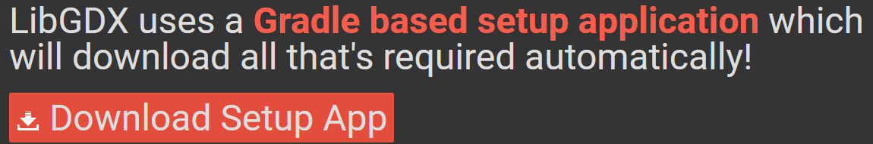
2. Unblock the file (if using windows)
   1. Right-click and chose properties
   2. Chose unblock, click apply then ok to close the properties.

## Installation Steps:

Technically there are no installation sterps because it is just a library that uses a build tool called Gradle to download the required library files. All the downloaded file does is creates an empty android studio project with gradle build options.

1. Create a new LibGDX project:
   1. See steps in Example below.

# EXAMPLE: Creating a LibGDX project, import to Android Studio, and upload to Github

Create empty LibGDX project:

1. Run the downloaded app (gdx-setup.jar)
2. Enter the following Information:  
   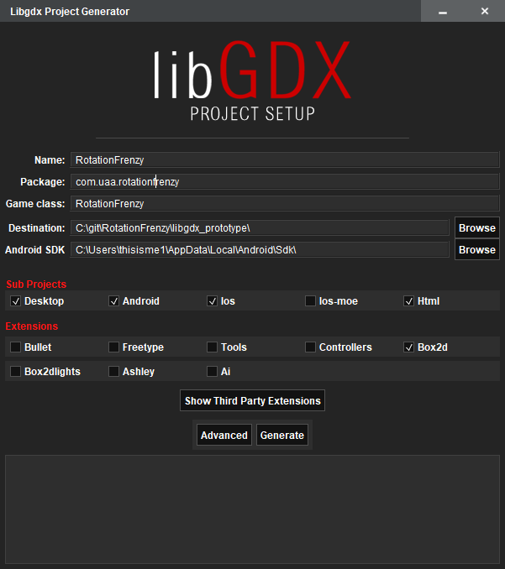
   1. **Name**: Name for your game or project
   2. **Package**: Package name, generally com.company.application
   3. **Game Class**: Root class name, generally CamelCase
   4. **Destination**: Where do you want the project to be created?
   5. **Android SDK**: I had to open Android Studio and go to Settings and search for SDK to find my location.
   6. **Sub** **Projects**: Desktop, Android, iOS and Html are the defaults, change what you want.
   7. **Extensions**: Box2d is the default, change what you want to add/remove.
3. Click Generate.
4. Possible warnings:
   1. 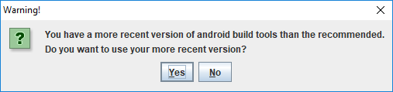
      1. You have a more recent version of build tools than is recommended. Do you want to use your more recent version?
      2. Click Yes.
5. Create a LibGDX project using the gdx-setup.jar file
   1. ***NOTE:*** *Pick your Android Studio location, as Android Studio doesn’t duplicate or move the files.*
6. Click yes to the comments about newer version of Build Tools
7. Wait for the project has finished being created.
8. Change the [**project.properties**] file to point to an older version of Android (14)
9. Open Android Studio and Import Project (Eclipse ADT, Gradle, etc)
   1. Select the build.gradle file from the new project you created with gdx-setup.jar.
10. Once the project is open, go up to VCS > Import Into Version Control > Share project on Github.
    1. Name the project and add a description.